Delete Patients from Secondary Database

# Primary and Secondary Databases

RayStation uses two databases: primary and secondary. In the **Open** case dialog, the color(s) of the dot beside the patient’s name tell which database the patient is in. Green means that the patient is in the primary database only (first patient in below screenshot), orange means secondary only (second patient), and orange-green split means both (last patient).

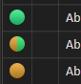

When you open a patient that is only in the secondary database, the files must be restored, and you will see a message saying such:

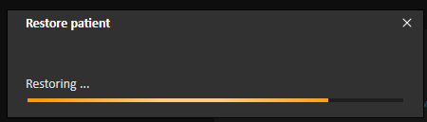

# Deleting Patients

Deleting a patient simply moves them to the secondary database. Unfortunately, users cannot delete patients from the secondary database, no matter how badly King and Ivan’s old phantom patients muddy the patients list. RaySearch can provide a command-line admin tool to our IT, but this overkill and apparently very slow and best run after hours.